Key-pair

Public key ---- .ssh/authorized_key (inside the server EC2)

Private key ---- downloaded in local laptop

.ssh-keygen ---- public key ---- id-rsa.pub

-----private key ---- id-rsa

How to recover? Deleted key

We are not using key here, only ip address

1.This is public server connect approach

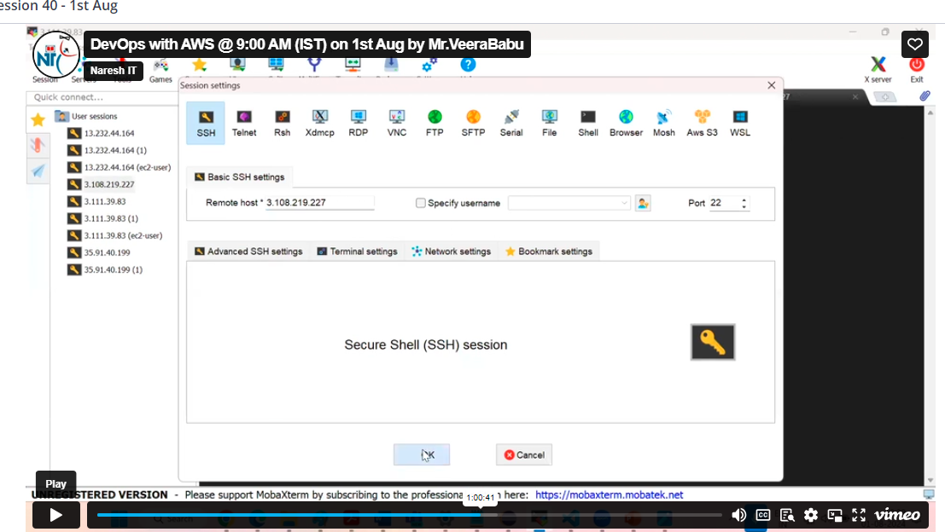

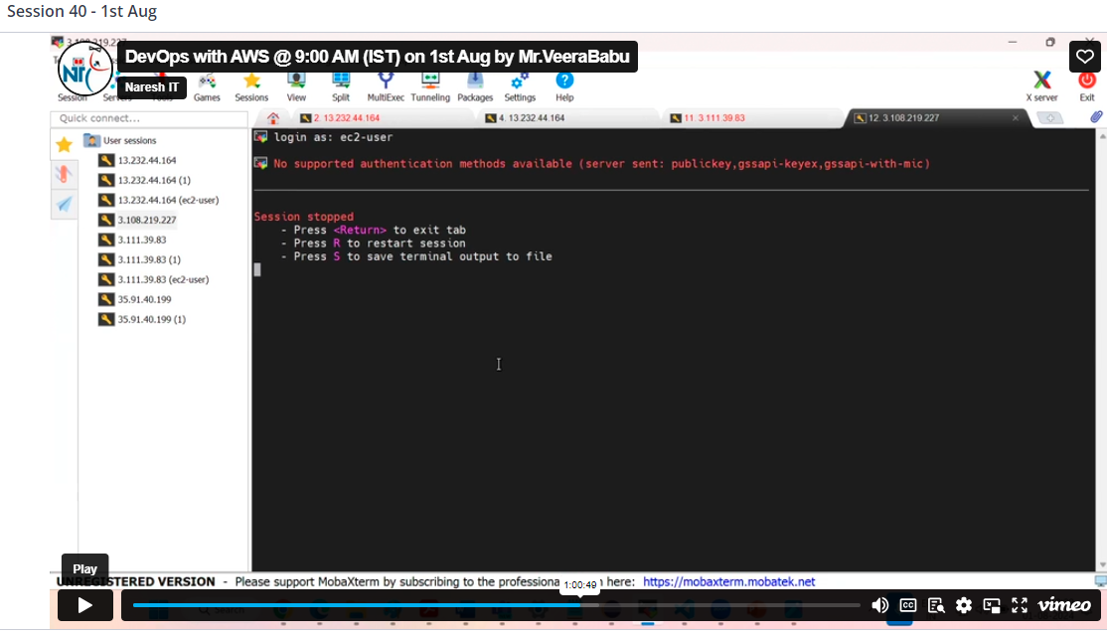

Your key had missed so you need to generate the key

Open CMD prompt vctl in your pc

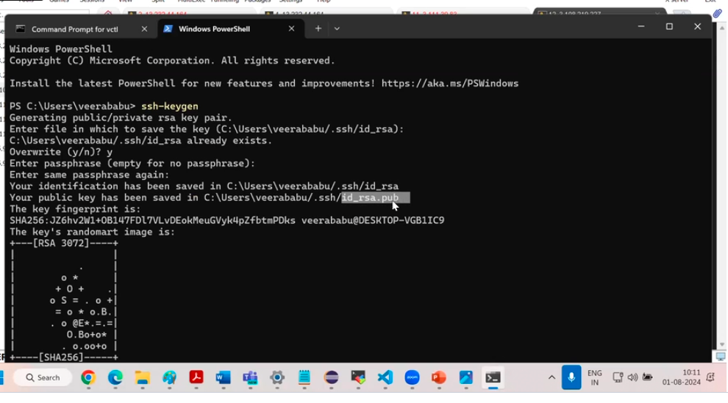

Now you can see the two keys saved in your local pc

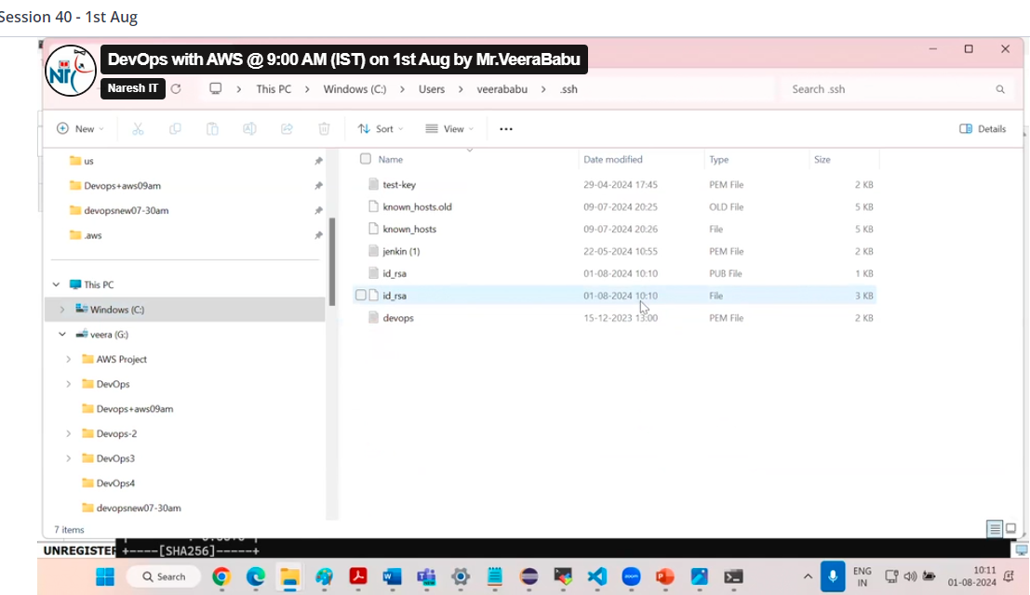

Here we need to upload public key into the server

For that we need to connect ec2 server by connect option

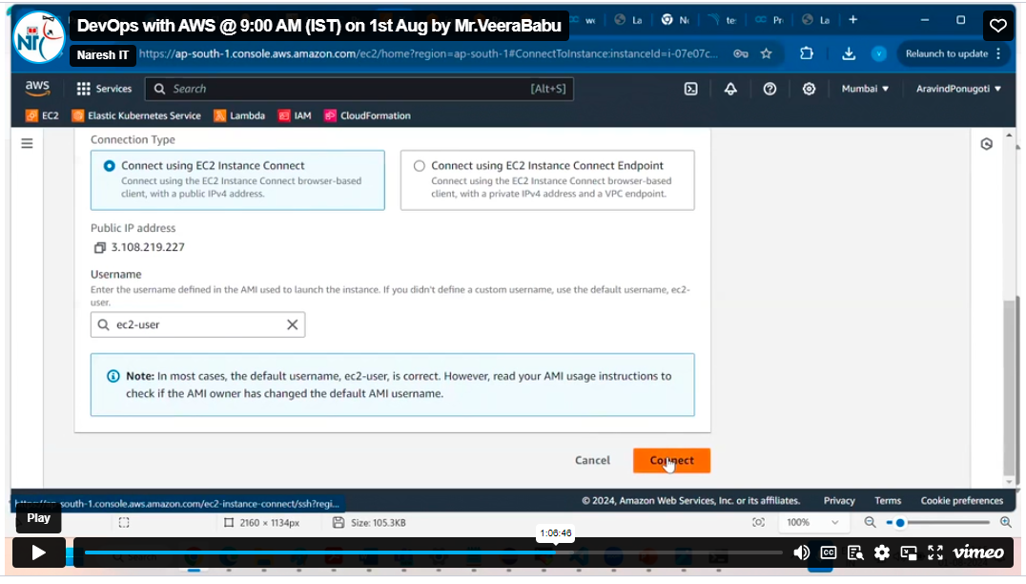

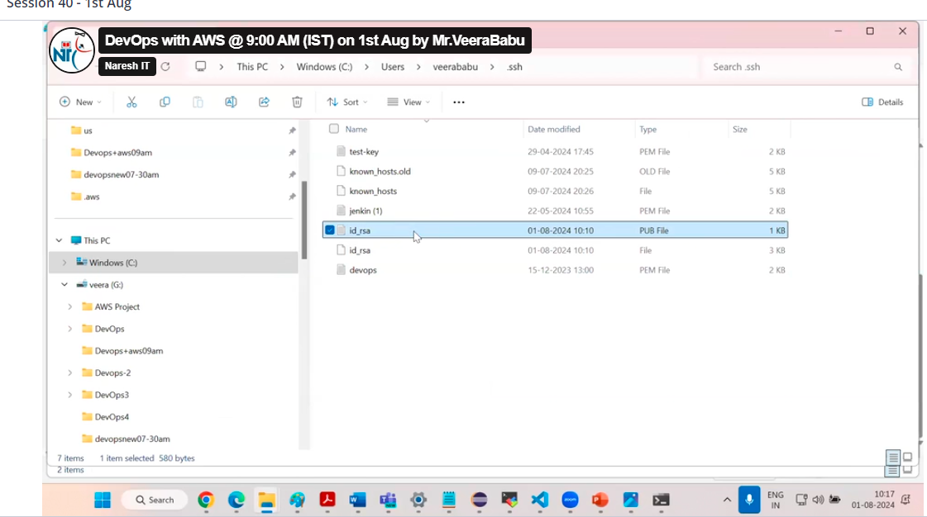

Save the key

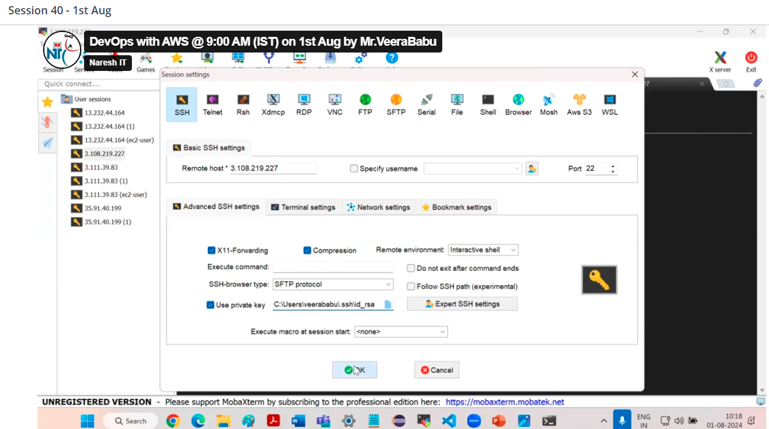

We have new download key by using key and public ip

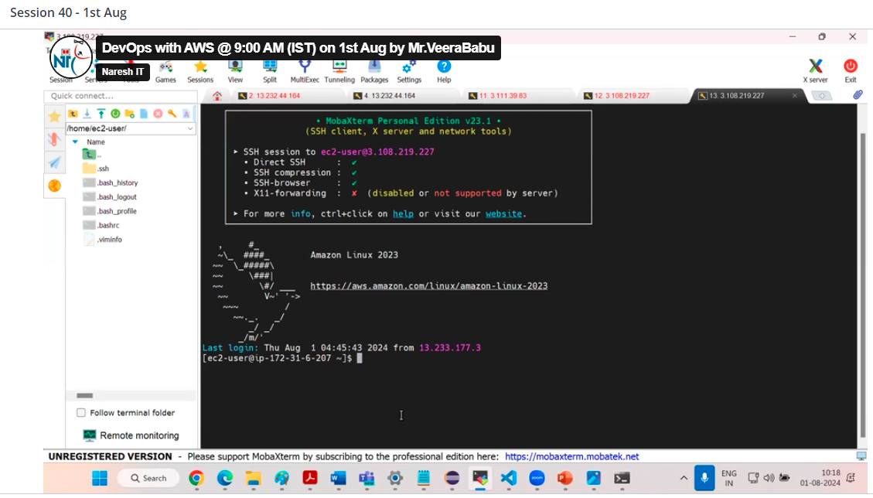

2.private EC2 connect approach

In this case we can use root volume of instance ,we can generate new keys in aws and by using back of instance in root volume, by using new key pair and root volume we can launch another instance and not required that much depth

so we can go with

stop the instance

